COUNTY OF MARIN EMPLOYEES HAVE ACCESS TO THE COLUMBIA SPORTSWEAR COMPANY EMPLOYEE STORE. THE STORE OFFERS CURRENT PRODUCTS FROM COLUMBIA, MOUNTAIN HARDWEAR, SOREL & PRANA 40-50% BELOW RETAIL.

INVITE DATES: OCT 4 - OCT 27 & DEC 13 - 24

CHECK YOUR EMAIL OR WITH HR FOR MORE INFORMATION!

STORE HOURS
LOCATION

MON - FRI: 11A - 8P 1414 HARBOUR WAY S.

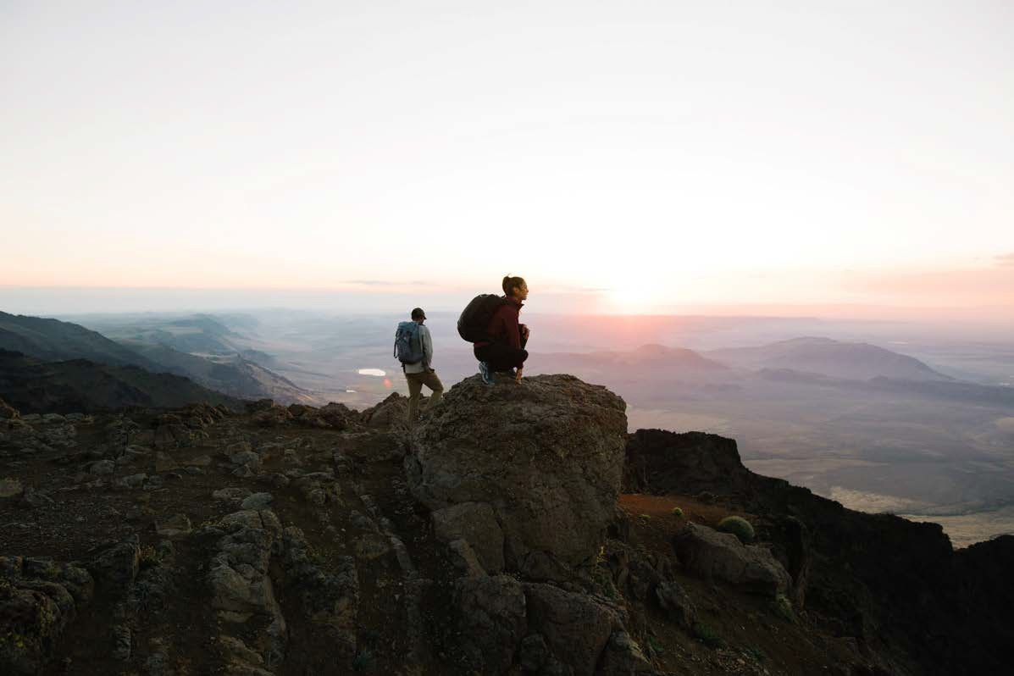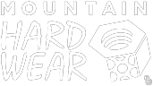
SAT - SUN: 10A - 8P
RICHMOND, CA 94804
510-558-2995

