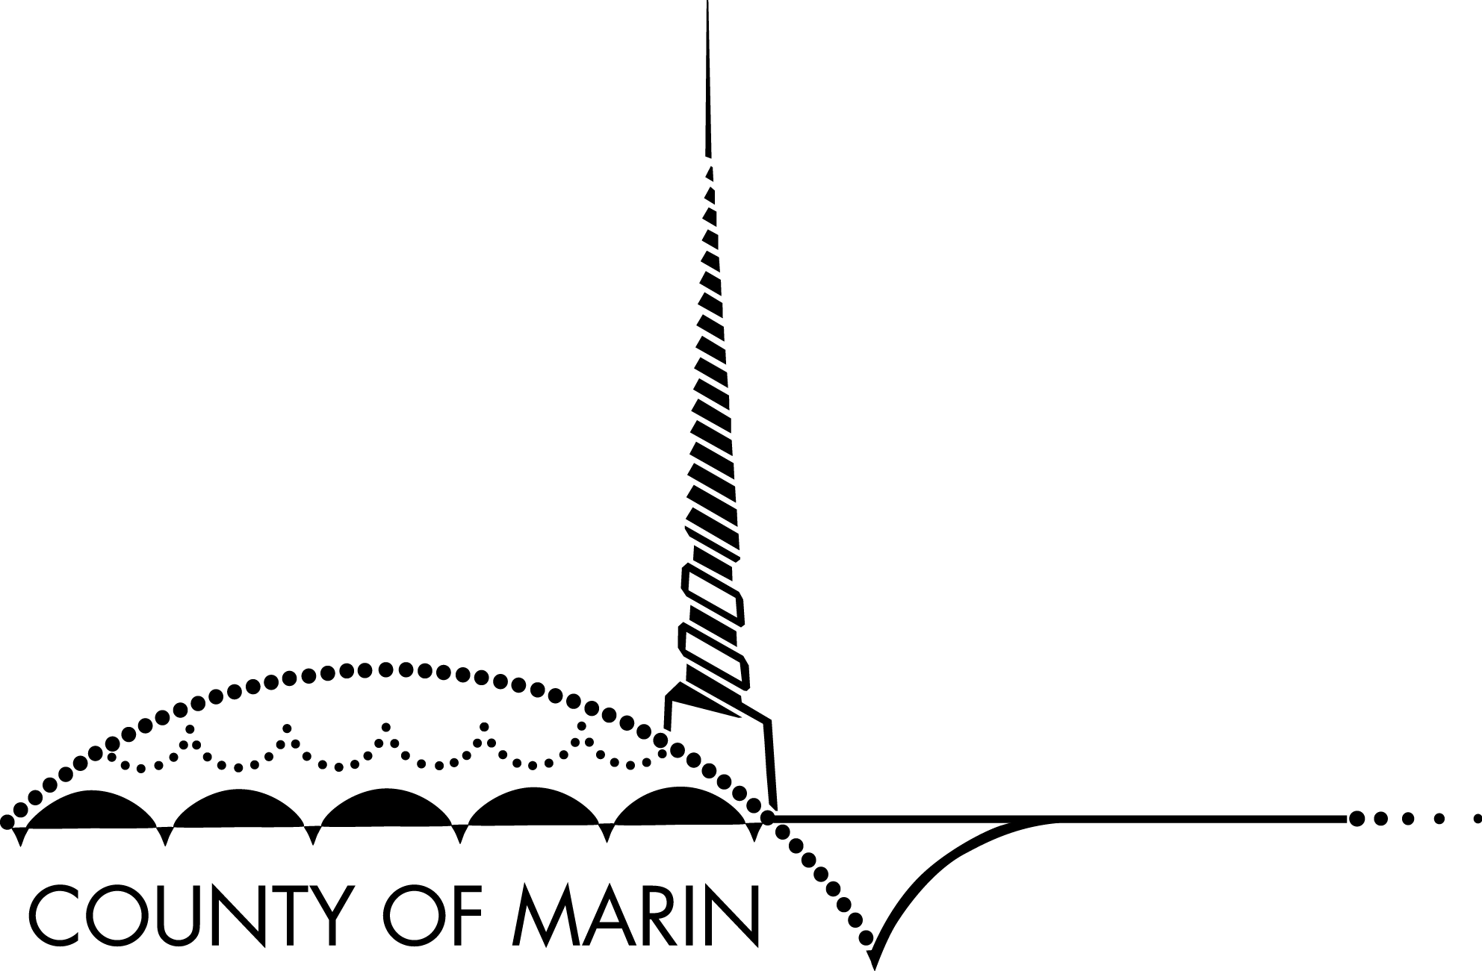
MARIN COUNTY PERSONNEL COMMISSION

Quarterly Meeting

April 18, 2018

Marin County Civic Center
Room 410B

Agenda
9:30 a.m. 1. Approve Agenda

2. Approve Minutes of January 31, 2018

3. Open Time for Items not on the Agenda

9:40 a.m. 4. Election of 2018 Chair and Vice Chair of the Personnel Commission

9:50 a.m. 5. Discussion – Personnel Commission Bylaws

10:00 a.m. 6. Scheduling – Grievance 16-09

7. Scheduling – Grievance 18-02

8. Scheduling – Grievance 18-07

9. Scheduling – Discipline Appeal D18-02

10. Scheduling – Discipline Appeal D18-03

10:15 a.m. 11. Presentation of the County of Marin’s 2018 EEO Plan

12. Director’s Report

. 13. Adjournment

Upcoming Meetings:

Date | Time | Location | Topic
July 11, 2018 | 9:30 am | 410B | Quarterly Meeting
October 10, 2018 | 9:30 am | 410B | Quarterly Meeting

All County public meetings are conducted in accessible locations.
If you require this document in an alternate format (example: Braille, Large Print, Audiotape, CD-ROM)
or if you require American Sign Language interpreters, assistive listening devices or other accommodations to
participate in this meeting, please call (415) 473-6172 (TDD) or (415) 473-6104 (TDD and Voice) or send
email to bbarry@marincounty.org as soon as possible but at least 72 hours in advance.
Copies of documents used in this meeting are available in accessible formats upon written request.
Late agenda material can be inspected in the office of the Executive Secretary to the Commission, between the hours of 8:00 a.m. and 4:00 p.m. weekdays in Room 415 of the Marin County Civic Center, 3501 Civic Center Drive, San Rafael.

